**Ruby – A chatbot to get your music admissions**

Chatbots are the AI and NLP based automated systems that provides quick information, which assists in resolving smaller problems. It increases the user experience of the customers and bring them closer to the firms. The main motive of chatbots is to give a more personal touch and increase the user interaction and for them to be in touch with our brand. A more personalised chatbot, can resolve the issues in hassle-free manner and decreases the human intervention. This leads to quicker solutions and smoother operations as well.

Background –

Ruby, is the chatbot for Shruthi Laya Music Academy, that assists in giving a quick information about the programs available and fee structure to choose. Depending on the courses chosen by the interested students, it redirects them to the main website and their information is locked with the academy.

**1 . Intents –**

Intent here, stands for what the customer has in mind. The query that they have to be resolved, is the intent here. Here, in this scenario, intents are the courses that they want to choose from the list of programs being provided by the academy to the students.

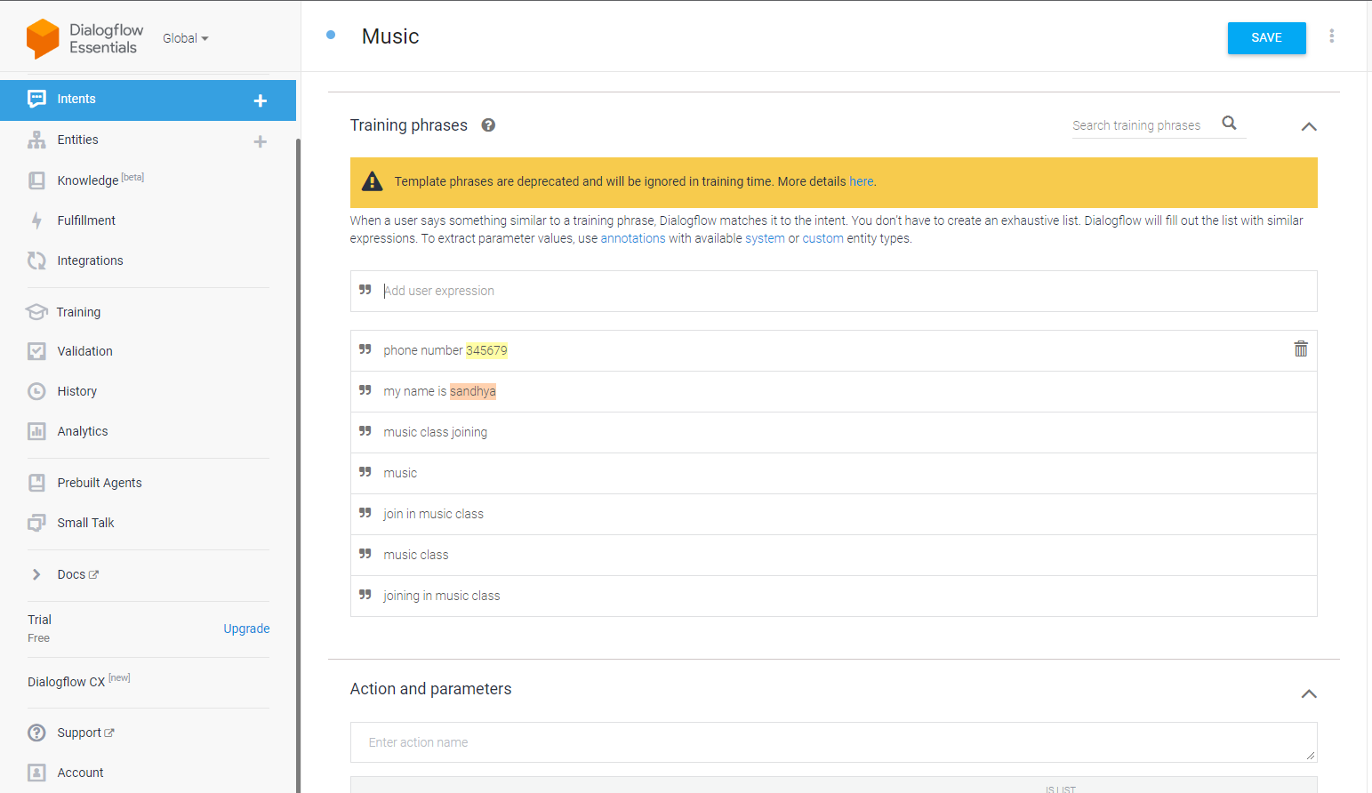

1.1 – Stating the basic intents

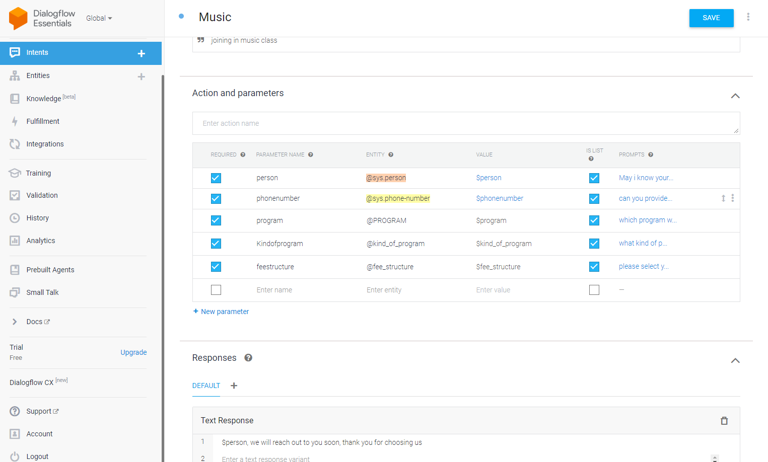

1.2 – Fixing the responses and the datatypes

**2 . Entities –**

Entity stands for the keywords that are extracted from the conversation that keeps going on. The entity can also mean the services that are being provided by the firm to the customers. In this scenario, the entities are – Carnatic Music, Light Music and Melody. These are the services that are being provided by Shruthi Laya Academy. These are again divided into various levels of specialisation .i.e. Certificate Course, Diploma Course and MA Course. These are again provided in 3 different fee structures which is flexible to choose.i.e. Rs.4000, Rs.2000 and Rs.1000. After these selections, Ruby will leave a message that the academy will reach out to the one who enquired.

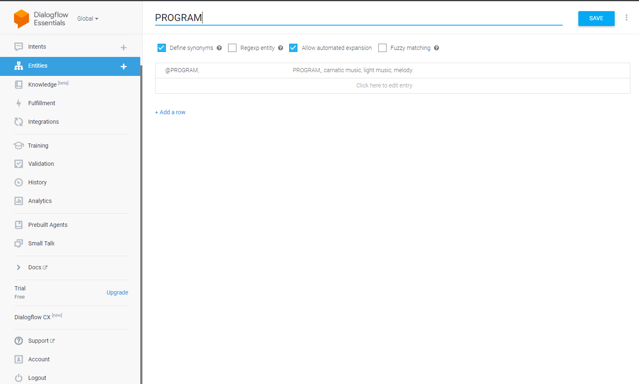

2.1 – Creating the list of programs available

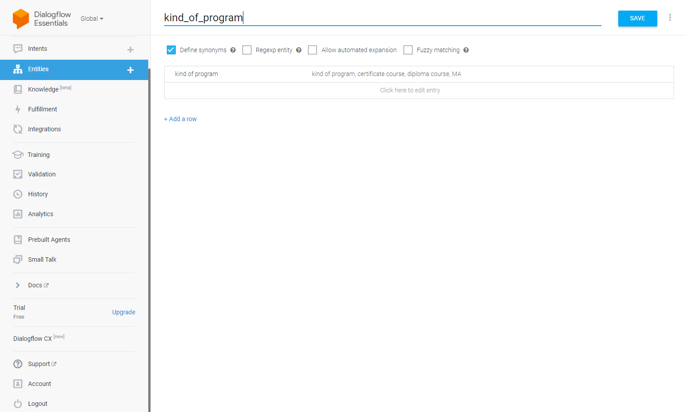

2.2 – Creating the list of various kinds of programs available

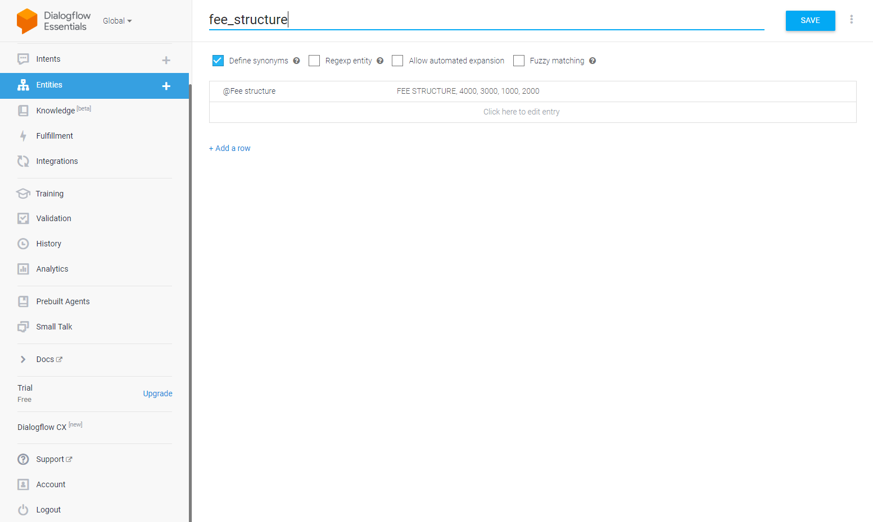

2.3 – Creating the list of fee structures available

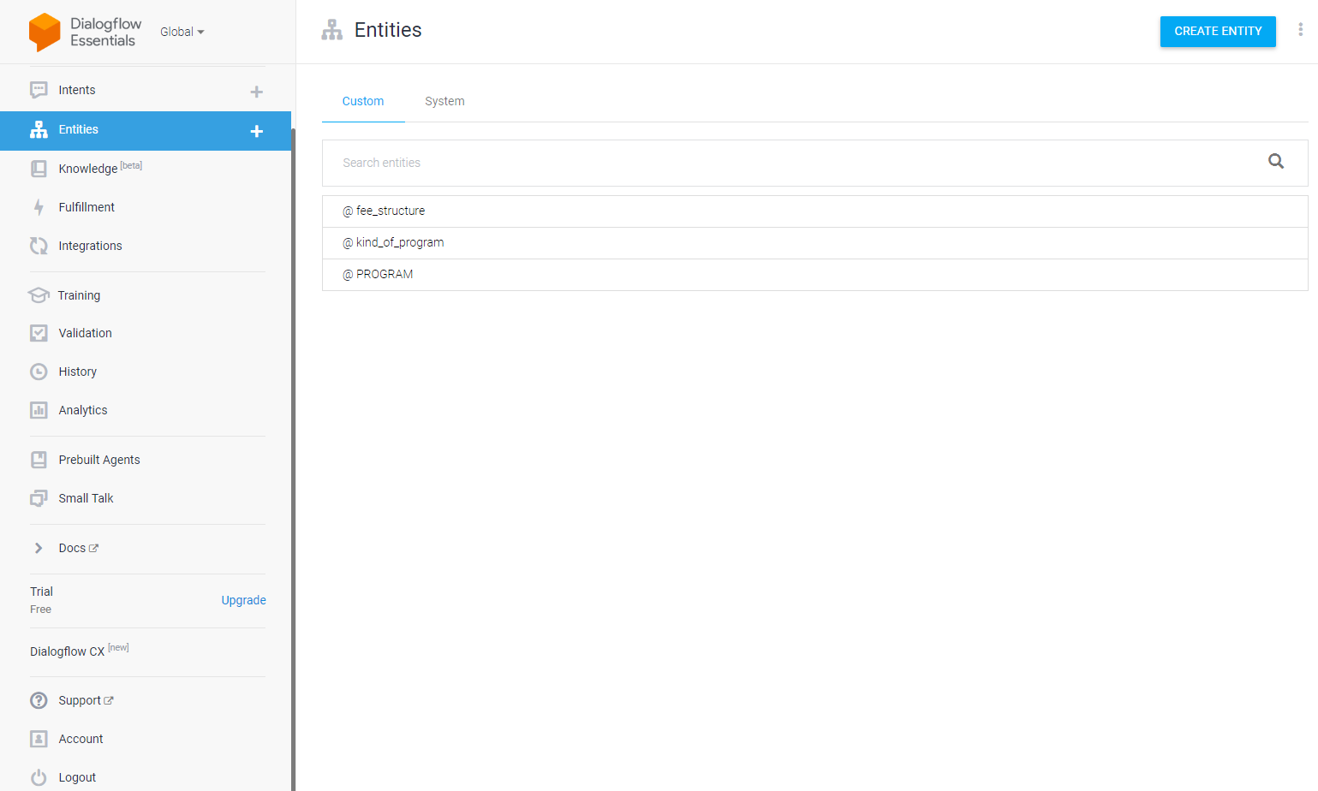

2.4 – Final list of entities created

**3. End Output Chatbot –**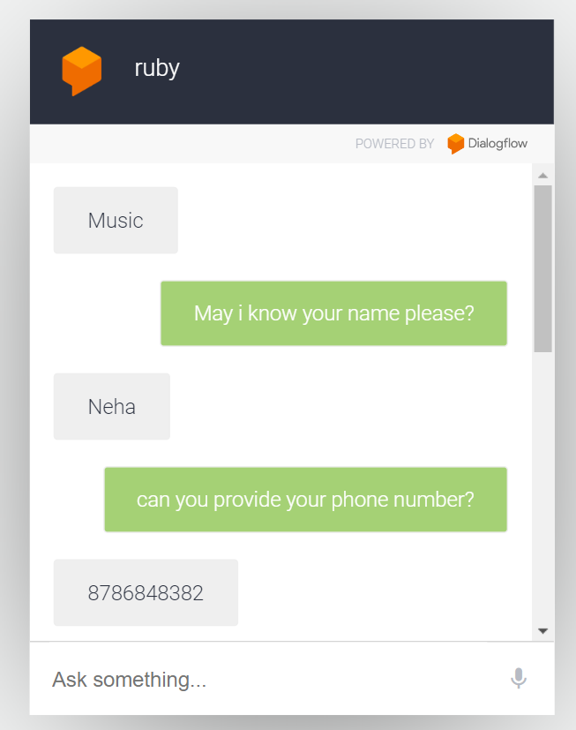

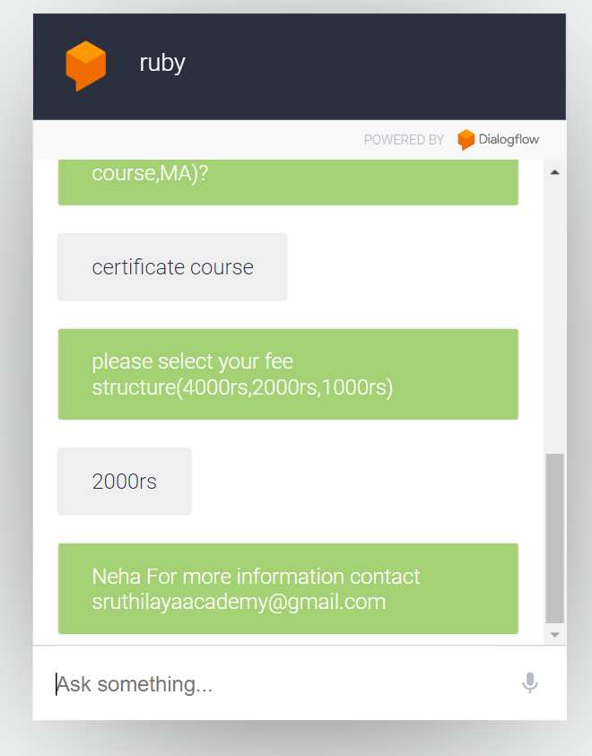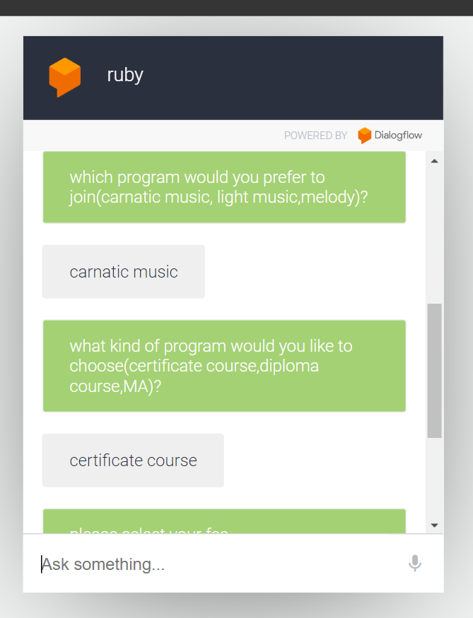

Link to chatbot - <https://bot.dialogflow.com/476c4b1b-409e-49e3-91b8-8c565996f050>

Link to GitHub - <https://github.com/gsrineha/data_analytics_portfolio>